Tableau Dashboard Analysis Report

By Darshan Patil

FIFA 21 Data Set

Context.

The datasets provided include the players data for the FIFA 21. The data allows multiple comparison of the same players of the videogame.

Some ideas of possible analysis:

* No of Players from each country
* The details about the players Information such as which club the player plays and which position, he plays for etc.
* Sample analysis of n% players to see if some important attributes as Agility or Ball Control or Strength. The trend of attributes is also an important indication of how some attributes are necessary for players to win games.
* Analysis on top 10 clubs which player has the highest release clause
* Analysis on the player contract details.
* Analysis on Attacking, Defending, Goalkeeping Attributes on each player
* Analysis on top 10 clubs with the highest paying wages
* Analysis on the highest over score in both club and country.

Dash Board 1:

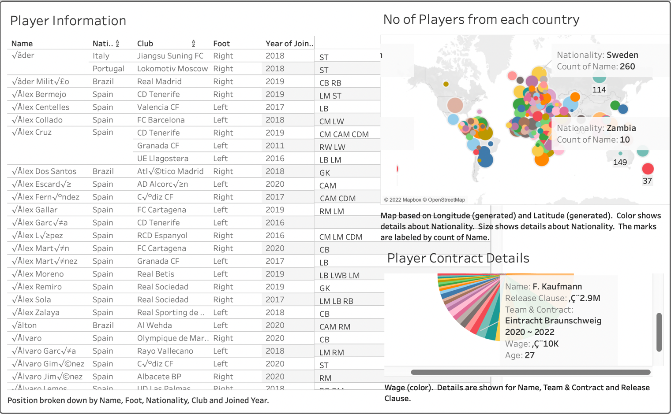

The Above Dashboard Gives us all the analysis on the Players Info and the number of players from each country.

This Dashboard also gives us clear information about the player contract details.

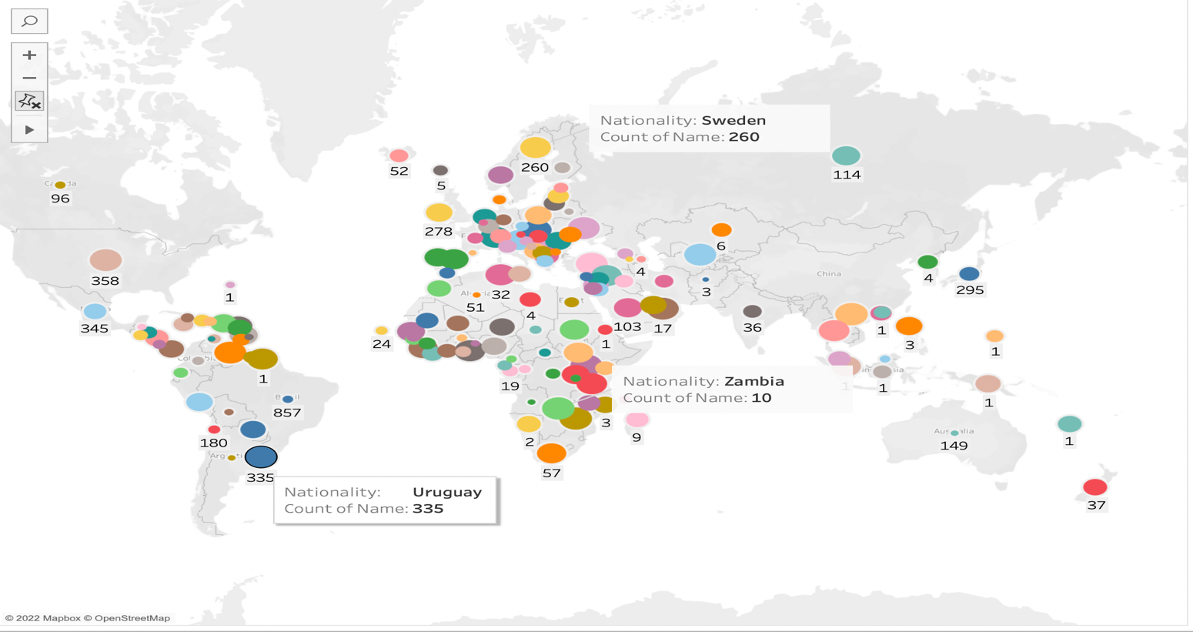

From the above Image and the annote you can see that the country Uruguay has a number of 335 players that have been produced in this gaming Data Set.

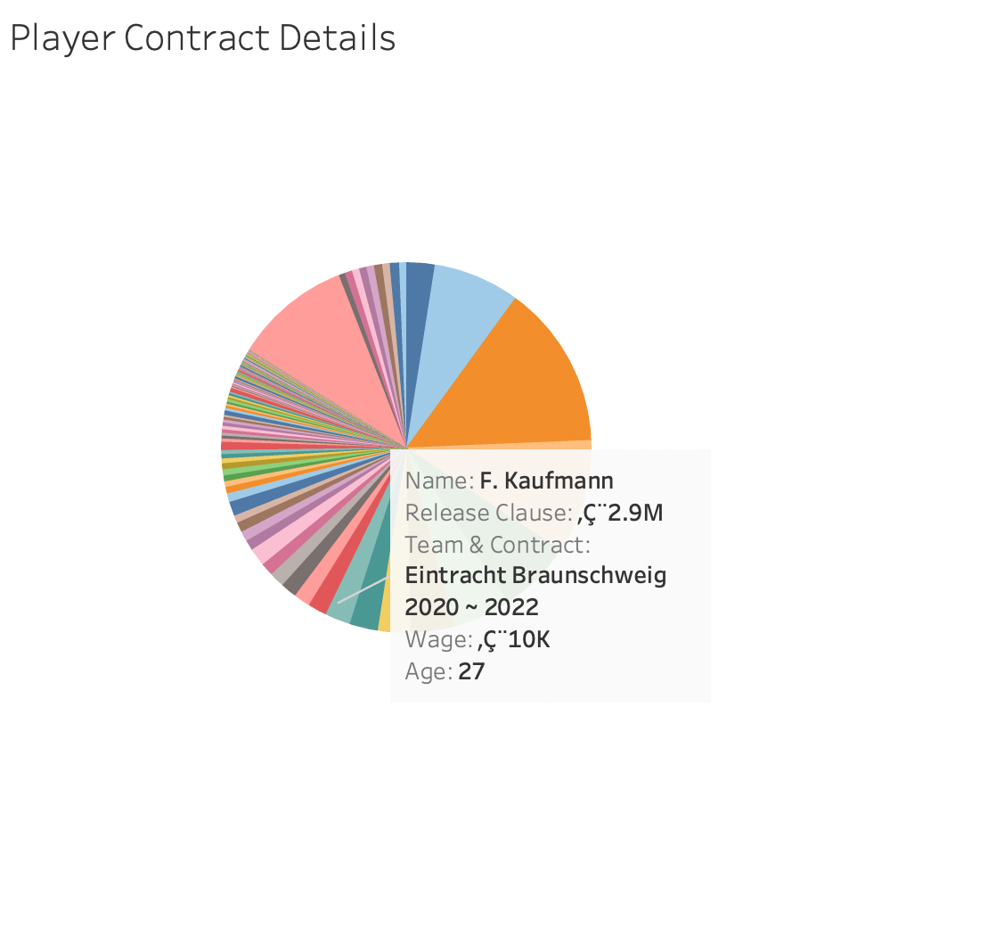

The Above Picture shows the analysis of player details such as the above example.

Where it depicts the players name, his release clause, the club he is playing for and the wages he is earning in that club.

Dashboard 2 :

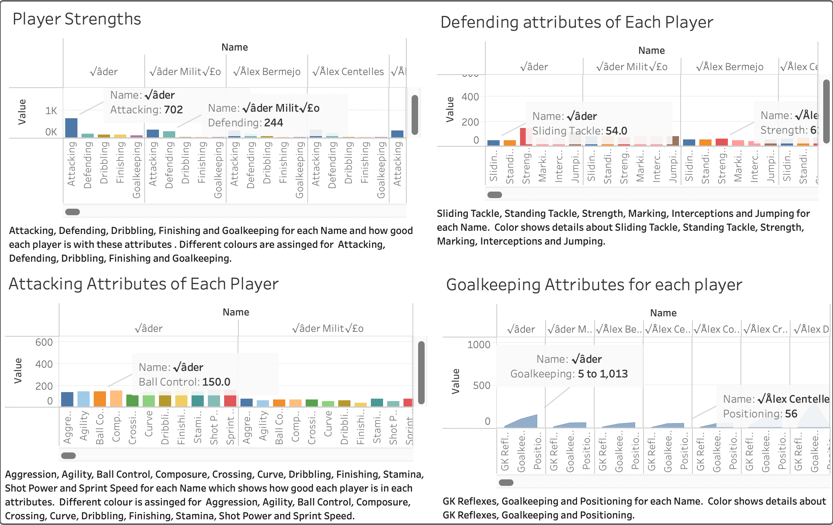

The Above Dashboard Shows the complete analysis on the players Attributes.

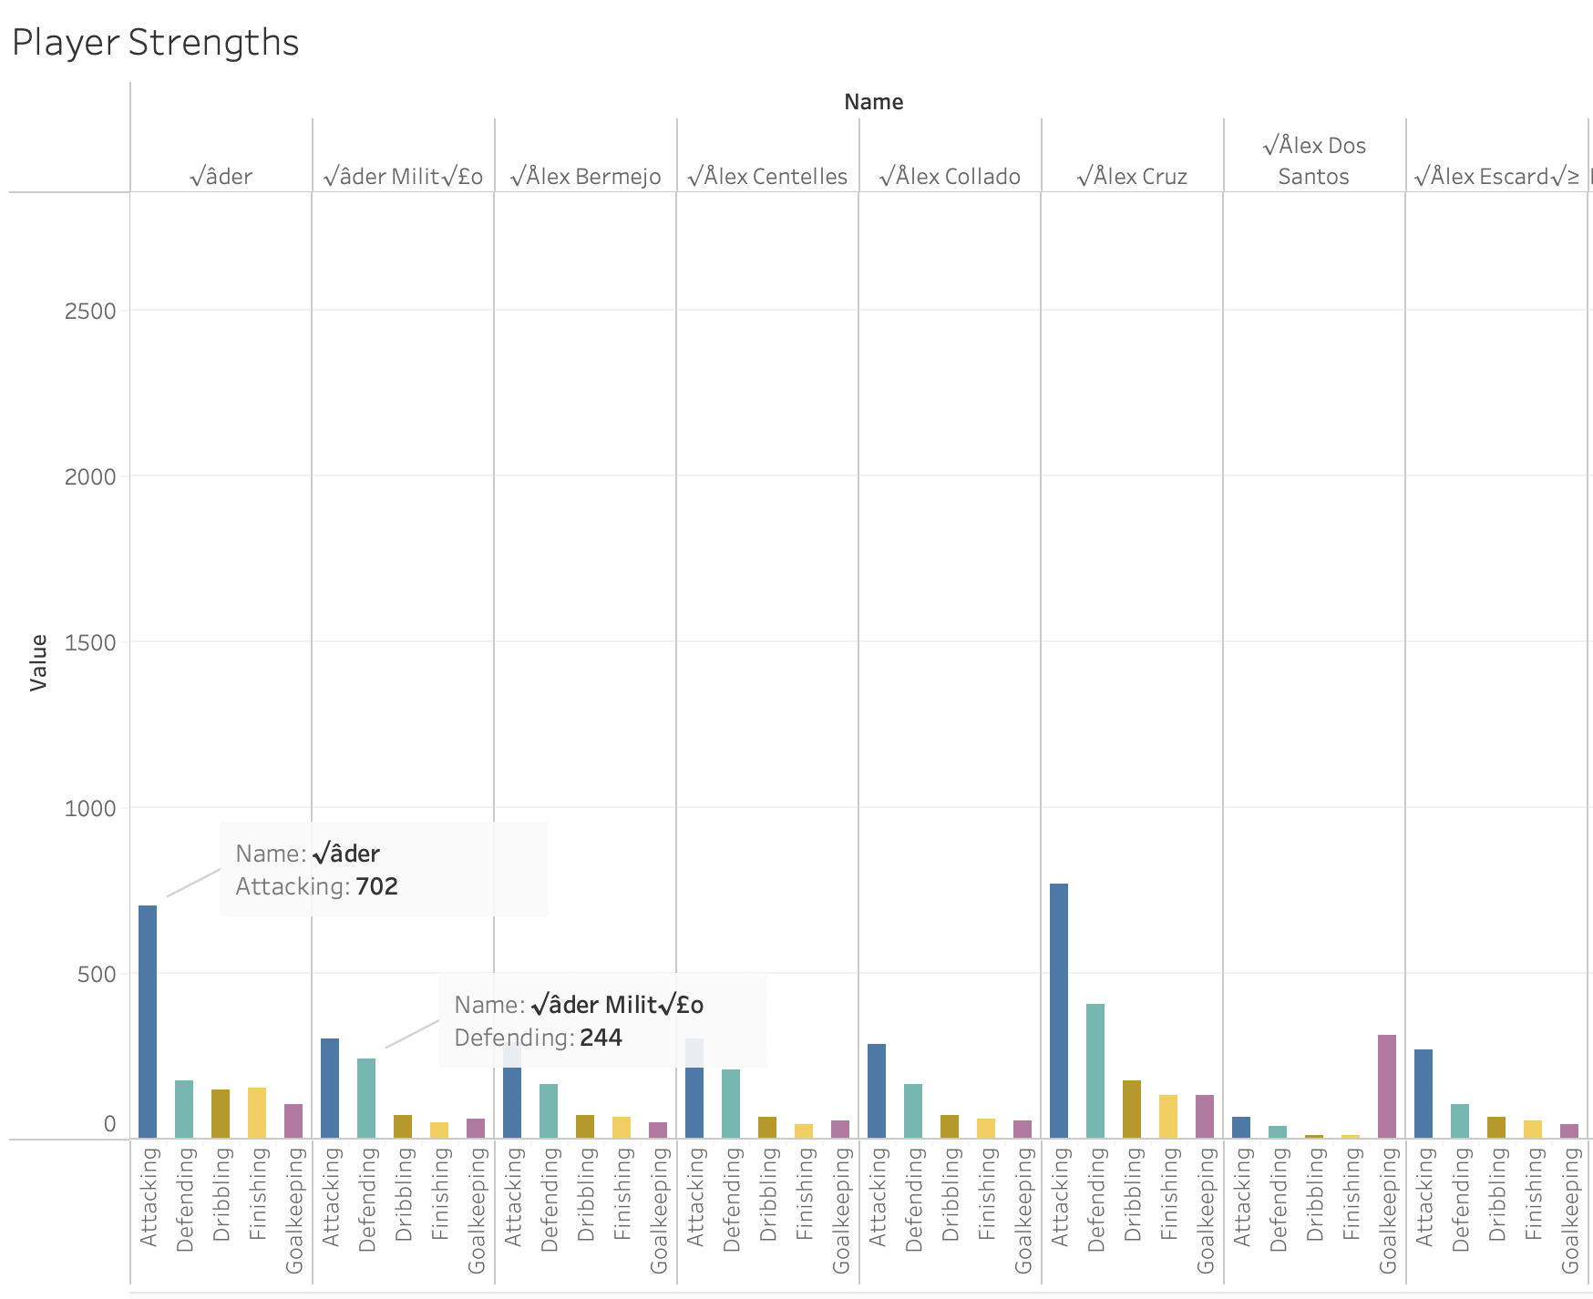

The Analysis shows the strengths that each players has to see if the player is good at one or more attributes (Attacking, Defending, Dribbling, Finishing and Goalkeeping).

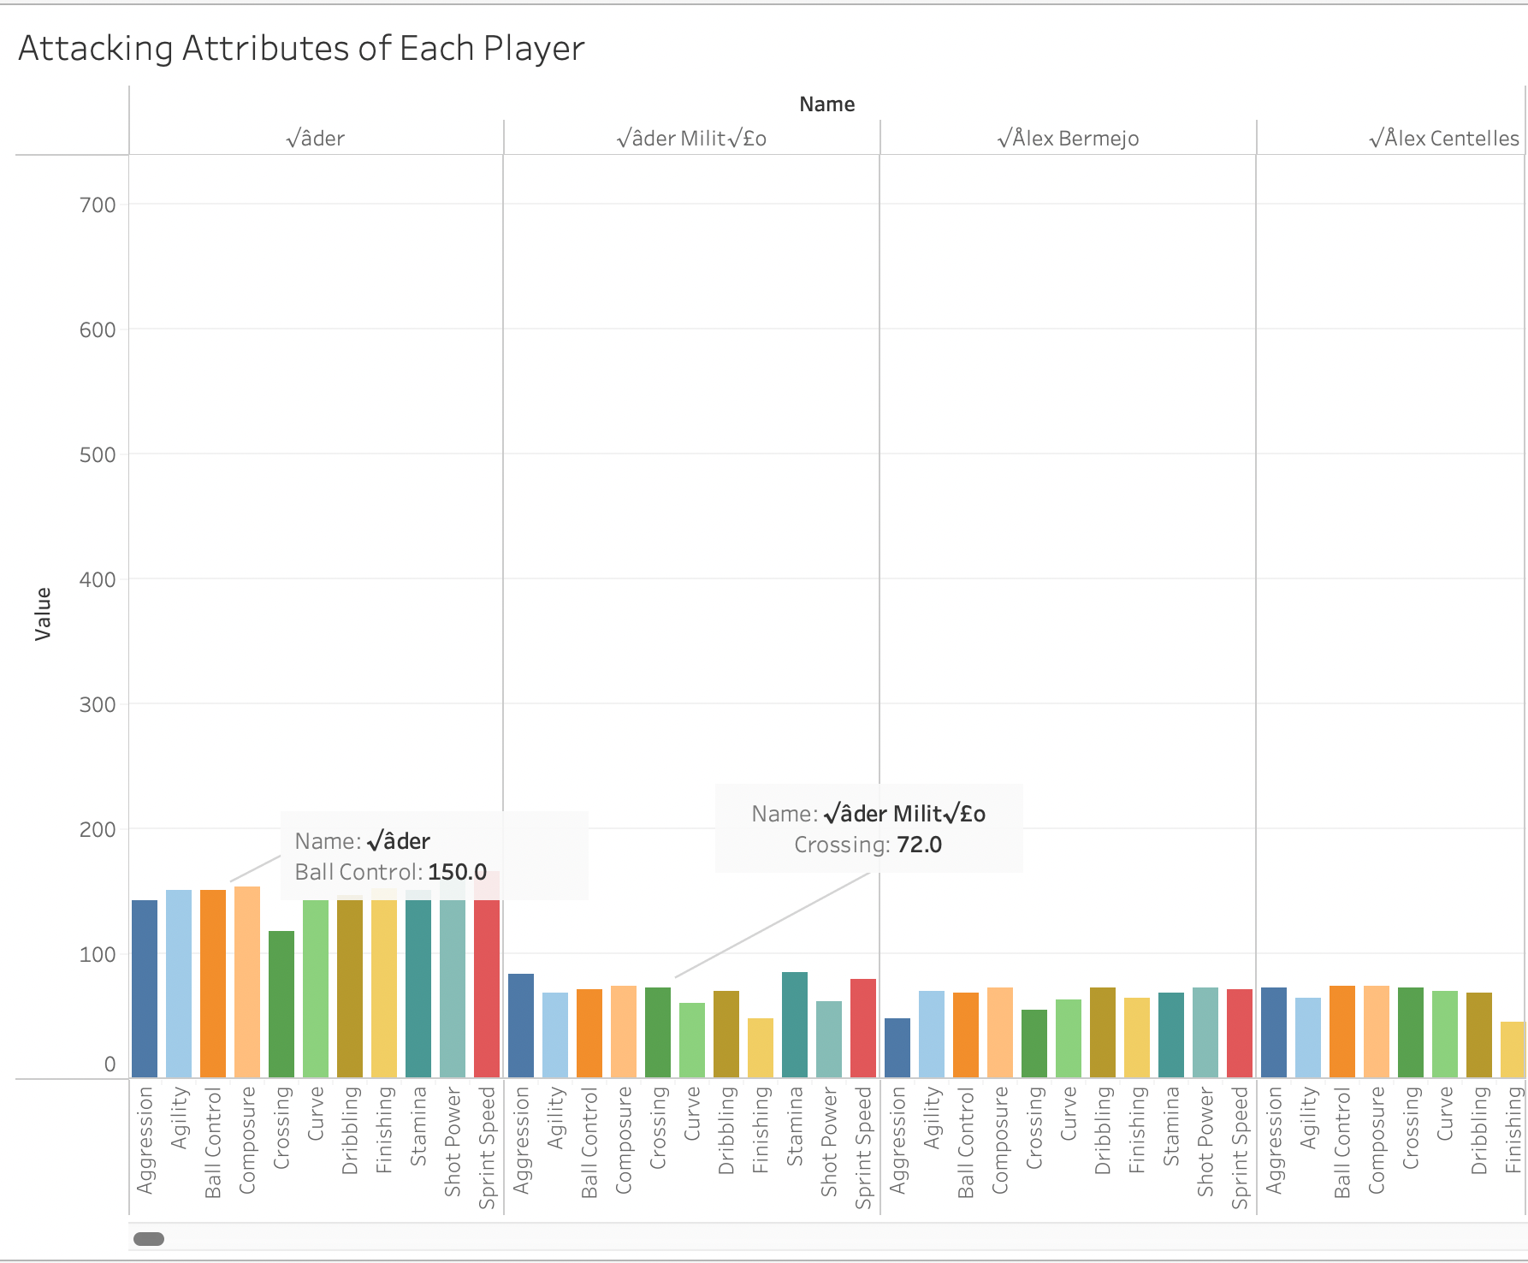

This Above analysis Shows how good a player is with the attacking attributes.

The players are compared with attributes such as Aggression, Agility,

Ball control etc.

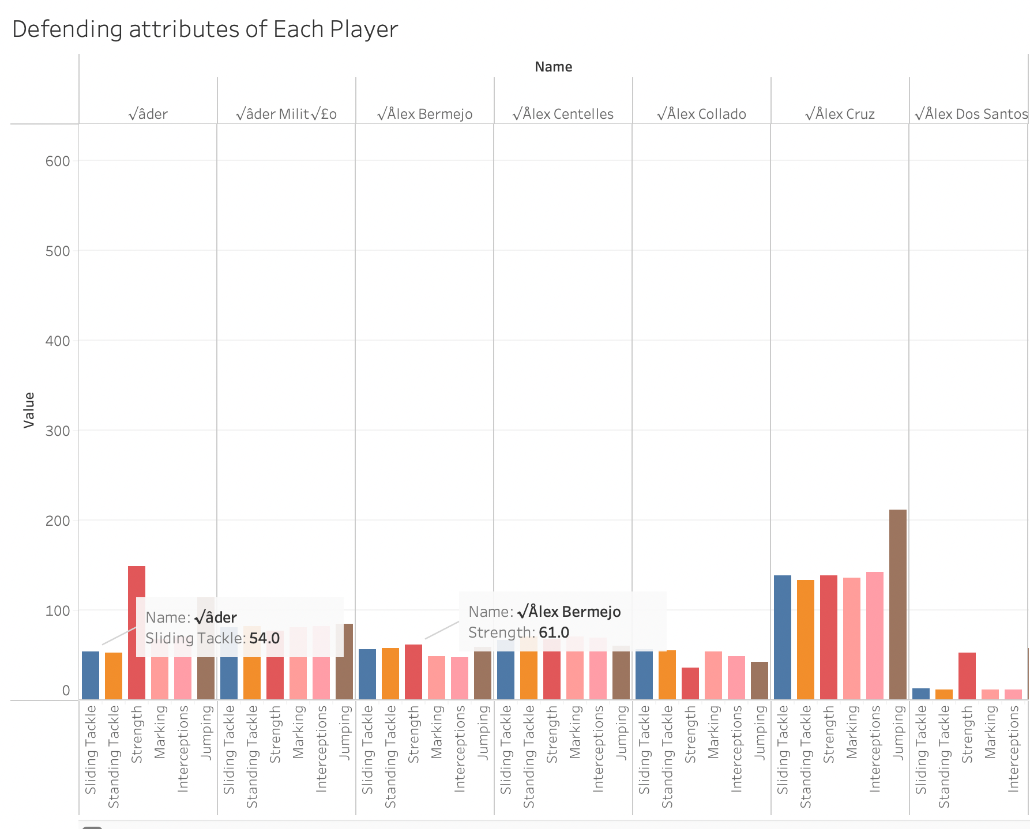

This Above analysis Shows how good a player is with the Defending attributes.

The players are compared with attributes such as Sliding tackle, Standing Tackle , Strength etc.

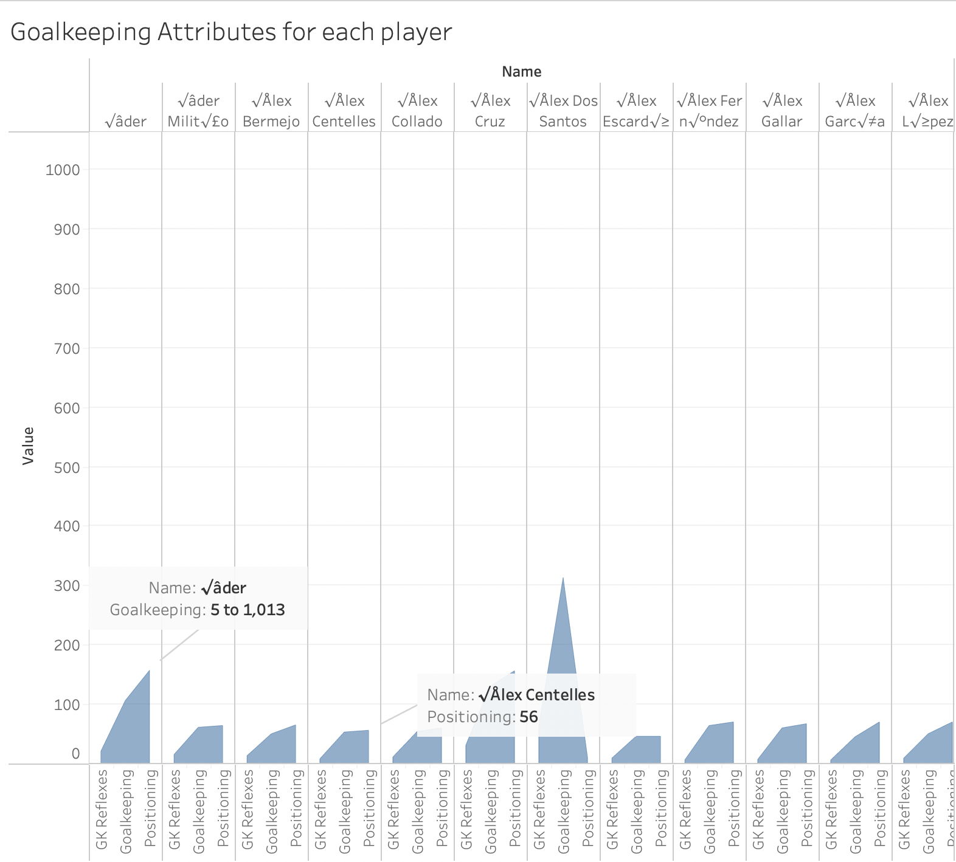

This Above analysis Shows how good a player is with Goalkeeping attributes.

The players are compared with attributes such as Reflexes, Positioning etc.

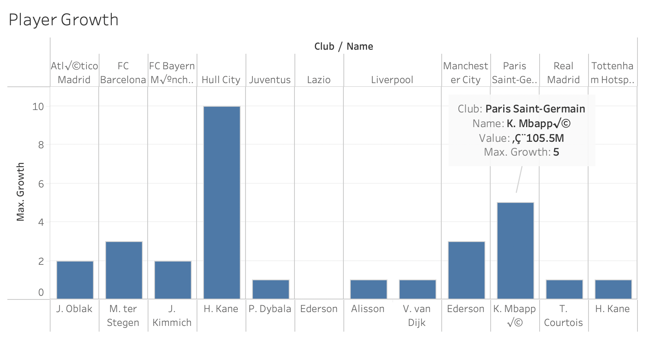

The above analysis shows the player that has the highest overall growth a player has done in the top ten clubs.

DashBoard 3.

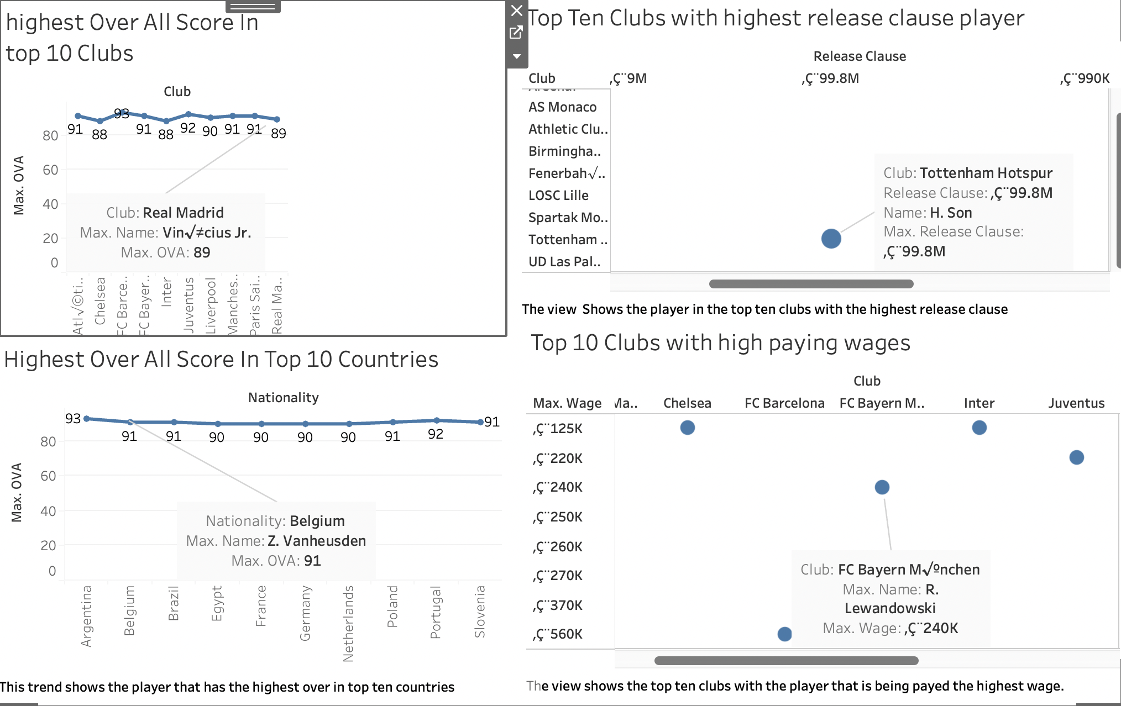

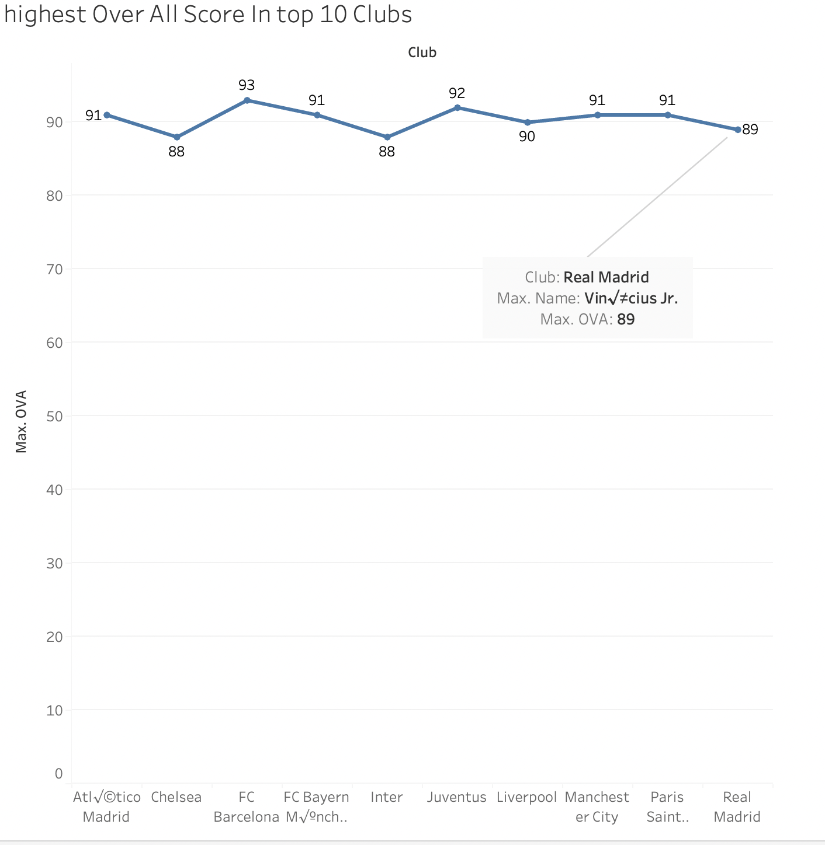

The Above Trend analysis shows the top ten clubs that have the player with the highest overall score.

For example, from the above analysis.

Name: Vinicius Junior

Club: Real Madrid

Max Over All: 89

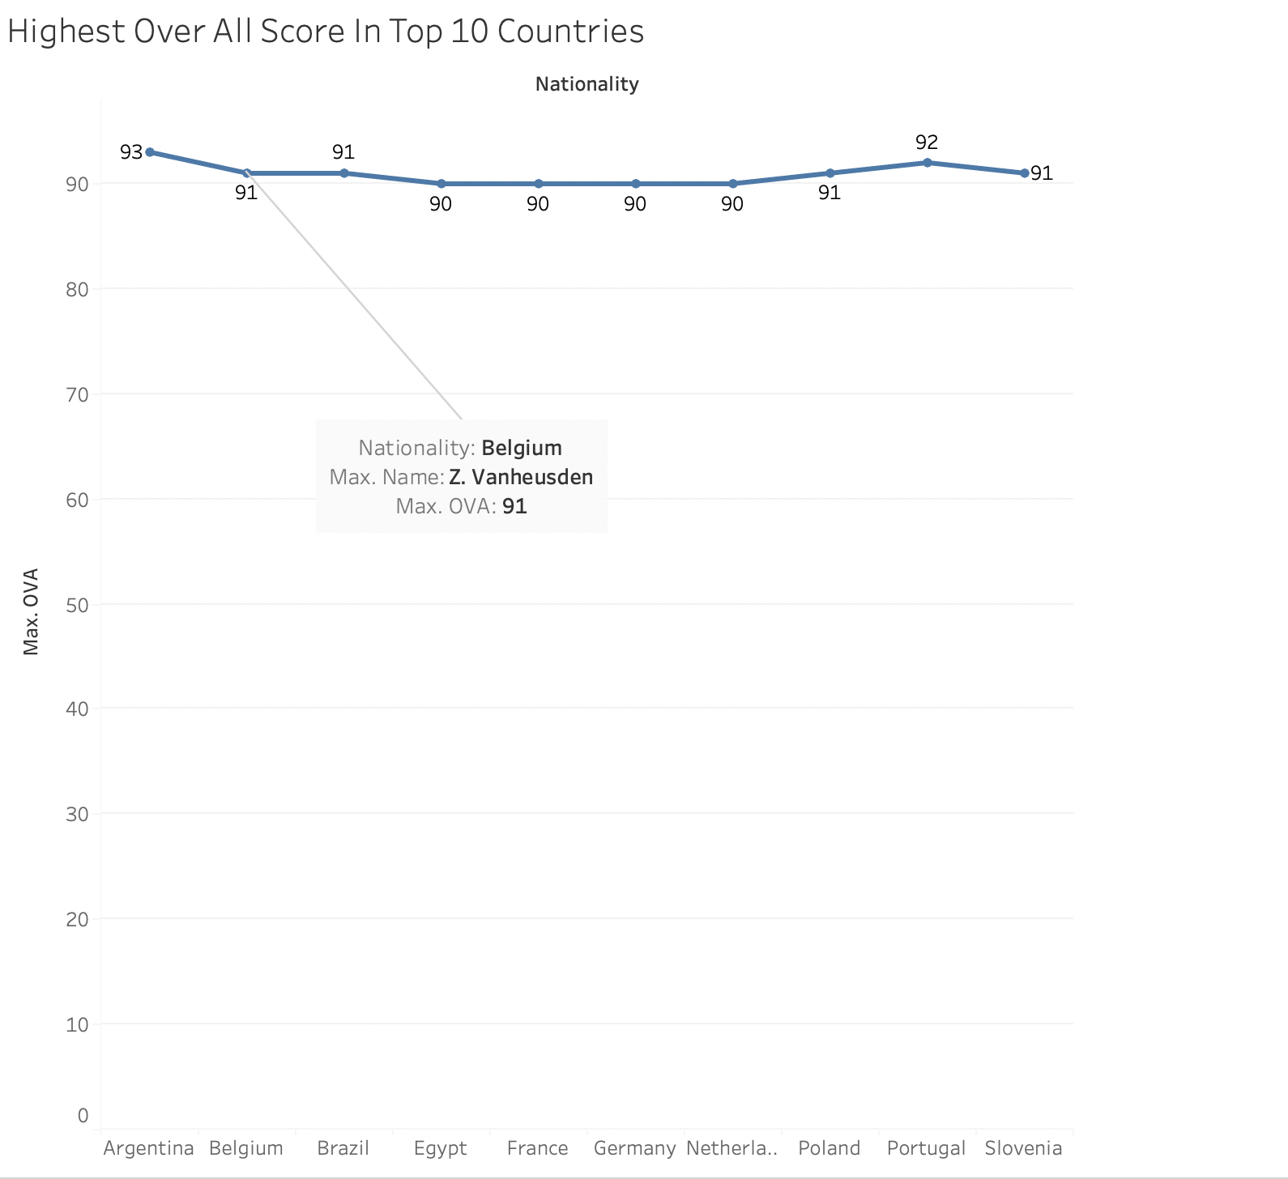

The Above Trend analysis shows the top ten countries that have the player with the highest overall score.

For example, from the above analysis.

Name: Z. Vanheusden

Country: Belgium

Max Over All: 91

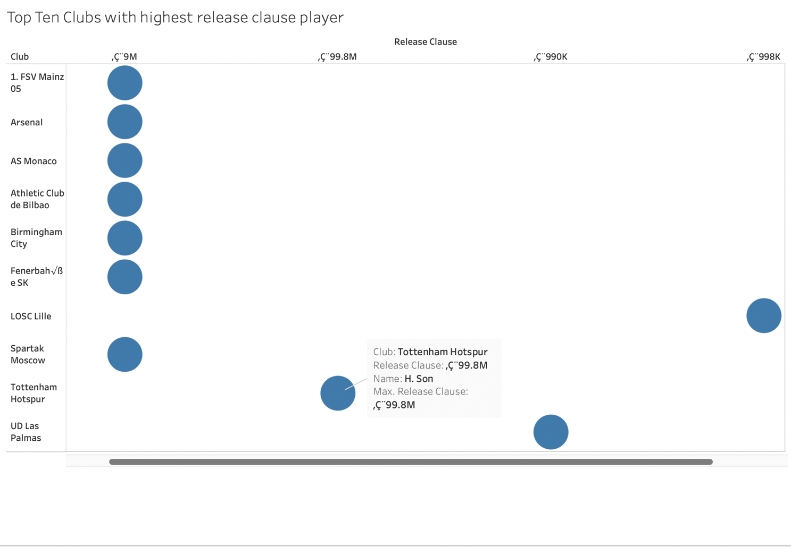

The Above analysis shows the top ten clubs whose player has the highest release clause.

For example:

Name: H.son

Club: Tottenham Hotspur

Max Release Clause: 99 M

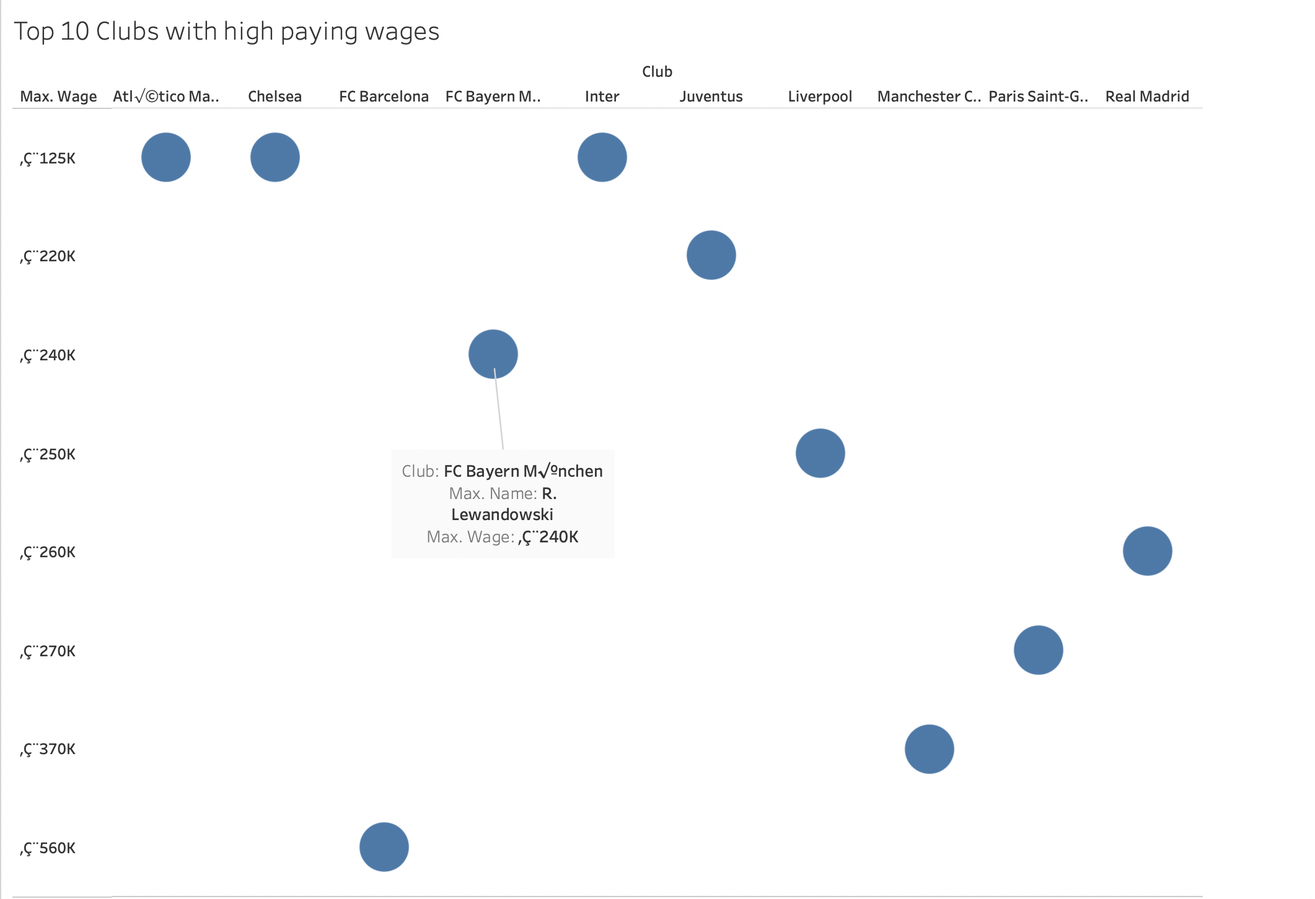

The Above analysis shows the top ten clubs which play the highest wage to the player:

Name: Robert Lewandowski

Club: Bayern Munich

Max wage : 240k